**Empowering Careers: Insights and Strategies**

**Introduction**

The objective of this analysis is to assess key metrics related to employee career development within the organization. By examining the average tenure, time in current roles, duration since last promotion, and education levels, we aim to identify areas for improvement and propose strategies to support employee advancement.

**Key Performance Indicators (KPIs)**

1. Average Years at Company
2. Average Years in Current Role
3. Average Years since - Last Promotion
4. Distribution of Education Levels

**Key Findings**

1. **Average Years at Company**

Overall Average: The average year of employees at the company is **7.01** years.

**Department Analysis**:

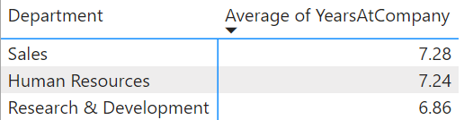

**Insights**:

* Sales has the highest average year at company (7.28), indicating strong employee retention.
* Research & Development has the lowest average year at company, suggesting potential retention challenges.

1. **Average Years in Current Role**

Overall Average: Employees have spent an average of **4.23 years** in their current roles.

**Department Analysis:**

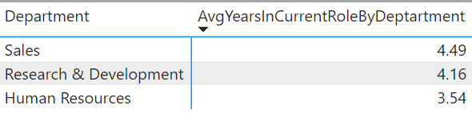

**Insights:**

* Sales again shows a higher average, which might indicate limited mobility or strong job satisfaction.
* Human Resources shows a lower average, which might suggest more frequent role changes or promotions.

1. **Average Years Since Last Promotion**

Overall Average: The average time since the last promotion is **2.19** years.

**Department Analysis:**

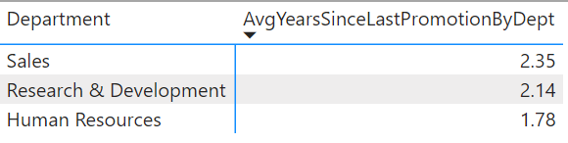

**Insights:**

* This suggests that the company has relatively frequent promotion cycles, which can be indicative of a dynamic and growth-oriented work environment.
* Employees in **Sales** have gone longer periods **without promotion** compared to other departments.
* Employees in **Research & Development** experience **more frequent promotion**, which indicates rapid career development opportunities due to innovation-driven growth and advancements in this field
* **Human Resources** show more **frequent** **promotion**, indicating a possibly more dynamic career progression path and a proactive approach to employee advancement within the department.

1. **Distribution of Education Levels**

Overall Distribution: Education level and Departments with employee count

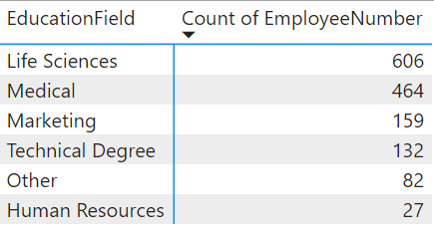

**Insights:**

• **Life Science (606 employees)**: The largest group, indicating a significant presence of employees with backgrounds in biological sciences or related fields.

• **Medical (464 employees)**: The second largest group, comprising professionals with backgrounds in medicine or healthcare-related fields.

• M**arketing (159 employees)**: Represents employees with expertise in marketing, emphasizing the importance of marketing skills within the organization.

• **Technical Degree (132 employees)**: Employees with degrees in technical fields such as engineering or computer science, reflecting a strong technical foundation.

• **Others (82 employees)**: A smaller group with diverse educational backgrounds not covered by the main categories.

• **Human Resource (27 employees)**: Employees specifically trained in Human Resources, focusing on HR management and employee relations.

**Additional Analysis with Job Satisfaction**

Analysing employee satisfaction and engagement regarding career development and promotions is crucial for cultivating a positive workplace culture, enhancing employee retention, and driving organizational success. These insights empower proactive talent management and resource allocation, fostering a highly engaged and productive workforce

**Steps**

* Show job satisfaction scores by department & gender

**Male Employee**

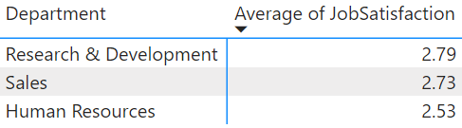

**Female employee**

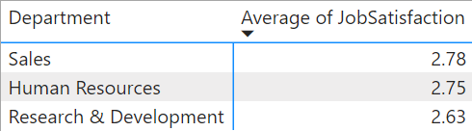

* **Correlation Analysis**: Explore correlations between job satisfaction and other variables like monthly income, education field.
* **Create Measures for Covariance and Standard Deviation -** Create a measure for covariance between job satisfaction and education field by using DAX.(covariance job education)

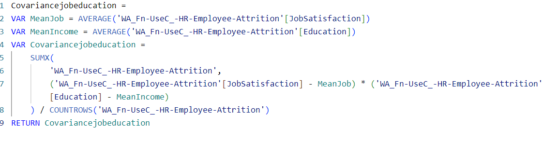

* Repeat this for other variable pairs (i.e) job satisfaction and monthly income by using DAX.(covariance job income)

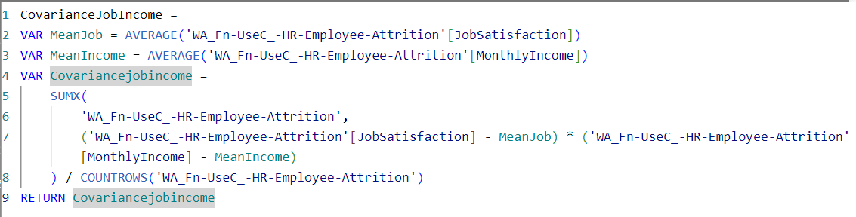

* **Create Measures for Standard Deviation**

**For Job Satisfaction:**



**For Monthly Income**



**For Education**



* **Calculate Correlation Coefficients**

**For Monthly Income and job satisfaction**



**For Education Field and job satisfaction**



* **Calculation of correlation with Job satisfaction and Monthly Income (Using DAX)**

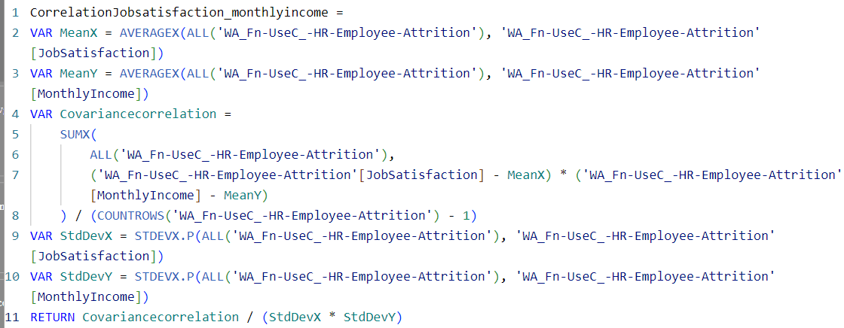

**Analysis**

* Correlation between Job Satisfaction and Monthly Income **(-0.02)**
* **Strength:** The correlation coefficient of -0.02 indicates a very weak correlation.
* **Direction**: The negative sign (-) indicates a slight negative relationship.

**Interpretation**

There exists a very weak negative correlation between job satisfaction and monthly income, indicating that as monthly income rises, job satisfaction tends to slightly decrease. However, the correlation is so weak that its practical impact is negligible.

* **Calculation of correlation with Job satisfaction and Education (Using DAX)**

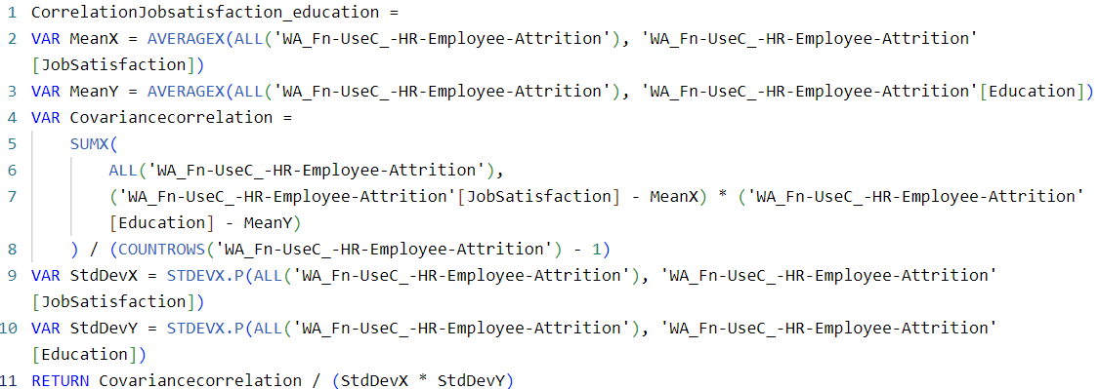

**Analysis**

* Correlation between Job Satisfaction and Education **(-0.04)**
* **Strength:** The correlation coefficient of -0.04 also indicates a very weak correlation.
* **Direction**: Similarly, the negative sign (-) indicates a slight negative relationship.

**Interpretation**

An analysis reveals a minimal negative correlation between job satisfaction and education level. This implies that as education level rises, job satisfaction may marginally decrease. However, akin to the correlation observed with monthly income, this relationship is exceedingly weak and lacks practical significance.

By Analysing, I conclude that while there is a slight tendency for job satisfaction to decrease slightly as monthly income or education level increases, these relationships are so weak that they are likely not practically meaningful. Other factors not captured by these correlations are likely more influential in determining job satisfaction.

1. **Areas for Improvement and Strategies for Advancement**

* The average length/ years of service at the company is **7.01** years, indicating a relatively stable workforce.
* Employees have spent an average of **4.23** years in their current roles. This suggests a need for more frequent role changes or promotion opportunities to prevent stagnation.
* On average, employees were last promoted **2.19** years ago. This longer duration may impact employee morale. - A majority of employees hold a Bachelor's degree, indicating a well-educated workforce.

**Improvement**

Based on the analysis, the following areas for improvement and proposed strategies are identified:

* Promotion Processes
* Training and Development Opportunities
* Retention Strategies
* Cross-Functional Collaboration
* Continuous Learning Culture
* Diversity and Inclusion Initiatives
* Strategic Alignment - career development with broader organizational goals and priorities

**Recommendation:**

* Enhance Diversity and Inclusion Initiatives
* Foster Interdepartmental Collaboration
* Promote Continuous Learning and Development
* Standardize Promotion Processes
* Implement Targeted Training Programs
* Develop Tailored Retention Strategies
* Leverage Employee Feedback
* Long-term Impact Assessment

**Conclusion**

In conclusion, through strategic enhancements in promotion processes, targeted training initiatives, a collaborative and inclusive workplace culture, and continuous learning opportunities, the organization aims to bolster career development and facilitate employee advancement. These data-driven strategies are designed to harmonize individual career aspirations with organizational objectives, fostering a motivated workforce capable of achieving high performance and sustained growth.